CDGI – New Claims Registration – Comments

Fields not required

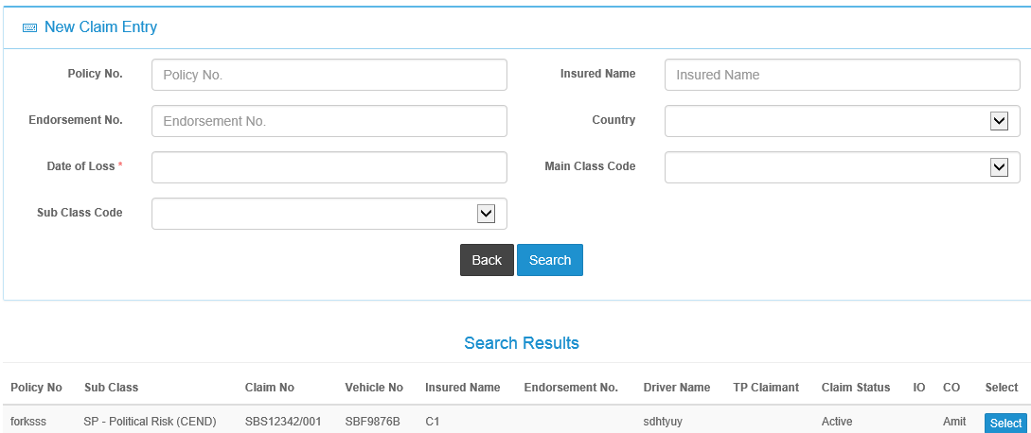

Based on Date of Loss, system will validate against Insurance Policy Master table in Admin to display the correct Policy No and info in Search results

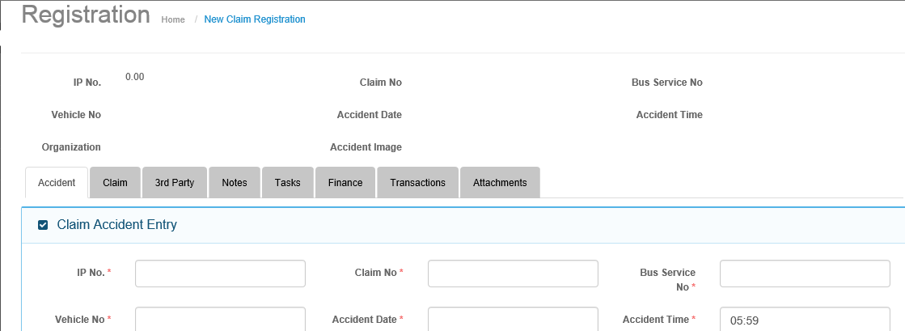

Finance tab is greyed at New Claims Registration

Time- HH:MM and PM/AM radio button

Date Picker

File Upload button – browse and attach

Look up table selection –CityCab, SBS Transit, Comfort Taxi, SMRT

Amend this field for DDMMYYYY entry

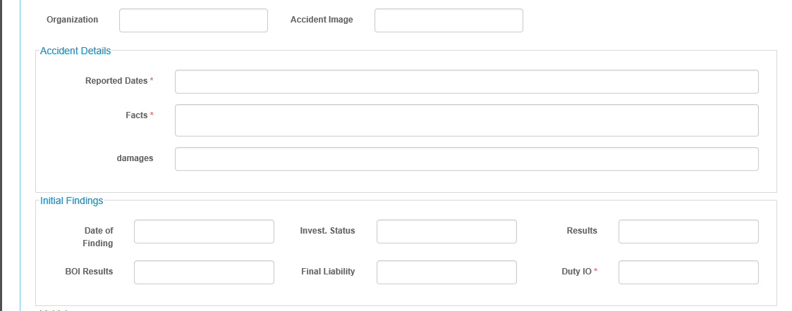

New Field – Any Third Party Claimant – Yes/No. If yes, 3rd Party Tab is available, if not , greyed

Date picker

500 chars

2 new fields –

Nature of Loss and Type of Loss – drop down selection from Admin masters

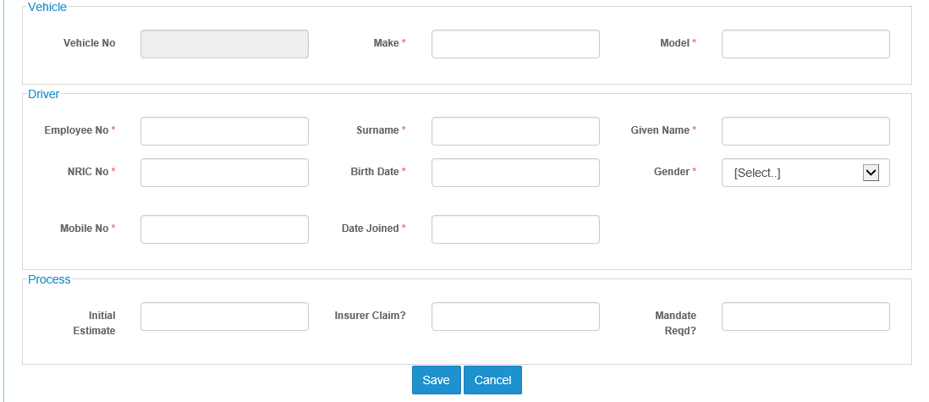

This is for system to recognize the process completed. Otherwise, this will appear in Incomplete Claims Registration

When Completed, this claim will be available for Claims Adjustments and Claims Payments and Claims Enquiry

System will validate that all mandatory fields are filled.

Message to display – New Claims Registration successfully completed

Claim Regd Completed

Search selection and populate the fields in Driver section from Bus Captain Listing master table

Based on vehicle no. in Admin Master, populate these fields

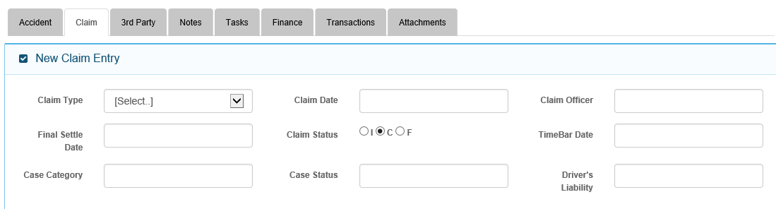

Mandatory fields

Compute ex rate multiply Reserve amount

Based on selected Curr, default ex Rate, compare system date falling within Rate period

Currency drop down selection from Exchange Rate Master

To check linkage for this drop down???

New block – before Claims Amount/Payout

Amount (Local Curr)

Amount (Local Curr)

View Reserve History

Reserve

Expenses

Curr

Ex Rate

Curr

Ex Rate

Total Reserve (Local Curr)

This will be a standard pop-up screen that user can view reserves made in respect of the specific claim. This History table is updated only upon completion of claims or payments processing

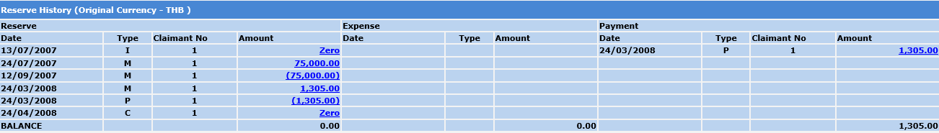

Amend Base to Local

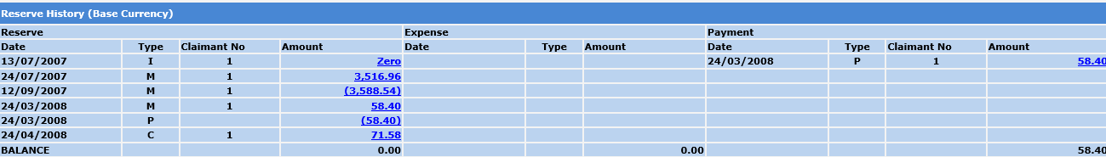

Same button for Claims Amount/Payout

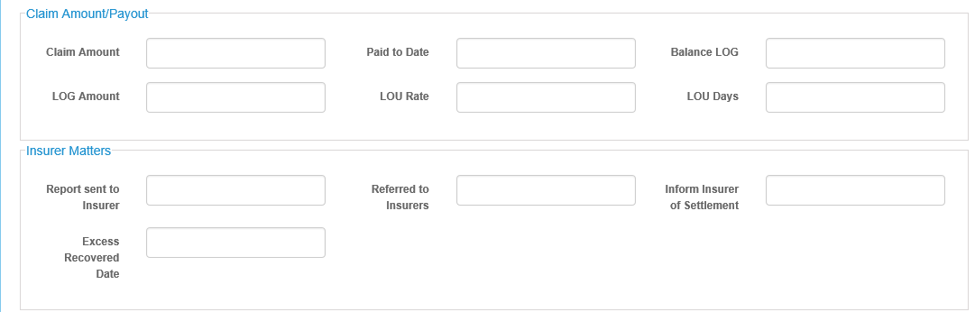

View Reserve/Payment History

Date Picker

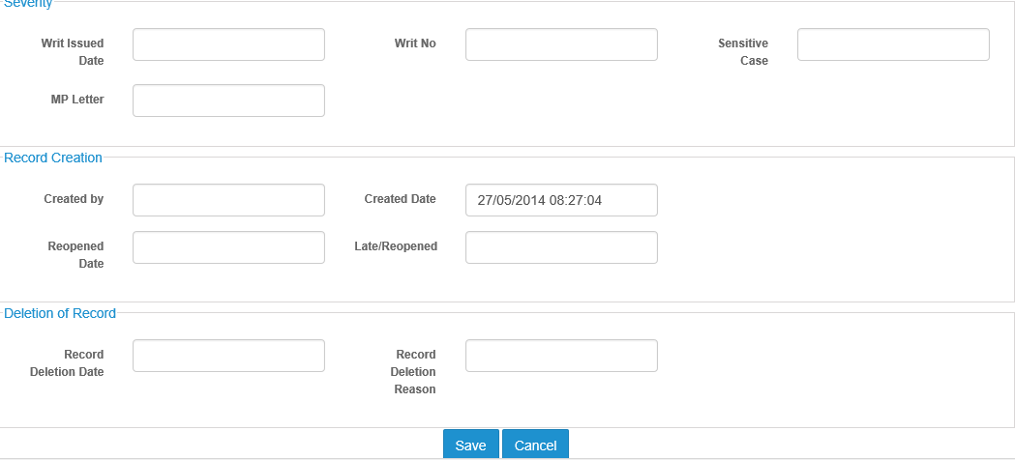

Admin Master

Depot/Workshop

Admin Master

Lawyer Appointed

Admin Master

Surveyor Appointed

Admin Master

User ID default

Adjuster Appointed

Date Picker

Creates Claim No. upon Save. Warning message if User clicks another tab without Click on Save button

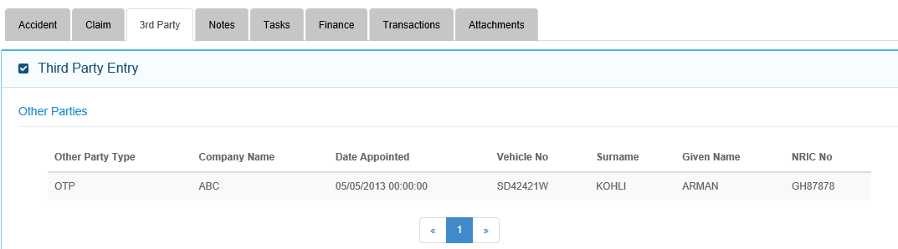

Column Headers – Other Party Type, Claimant Name, NRIC No., Vehicle Number, Loss Nature, Third Party Lawyer, Third Party Adjuster, Status

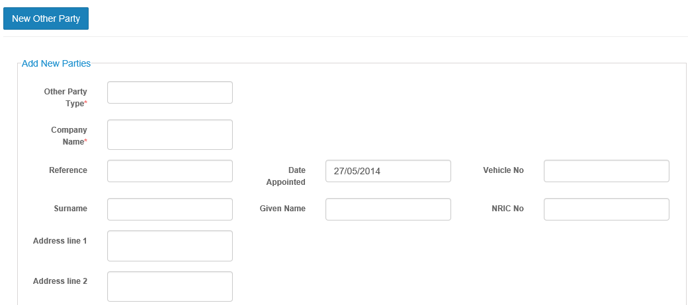

Re-arrange fields so that layout is more effective

Default to Singapore

Claimaint Name

Fields not required

Look up table – Third Party Claimant

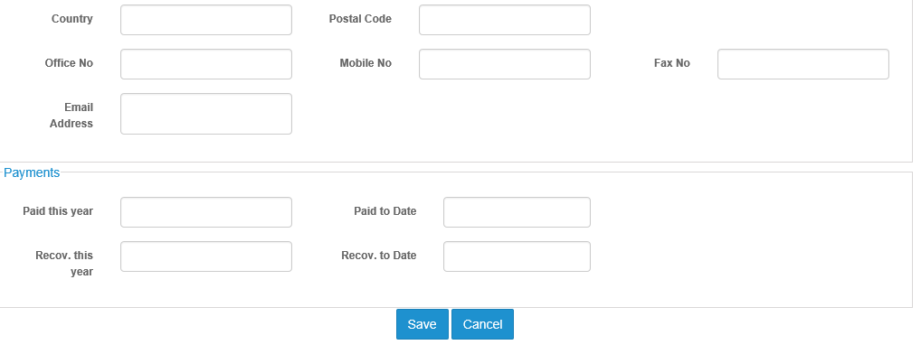

Same report view as in Reserve but only for this Claimant

View Payment History

Third Party Workshop

Free Text

Third Party Lawyer

Free text

Third Party Adjuster

Free Text

Incomplete Claims Registration

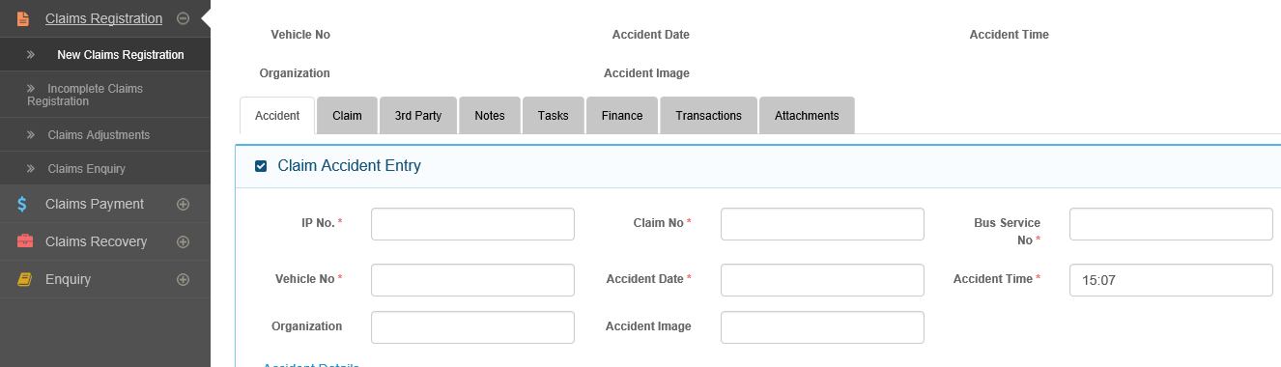

This will work the same as New Claims Registration until Claims Registration Completed button clicked.

Claims Payment Processing

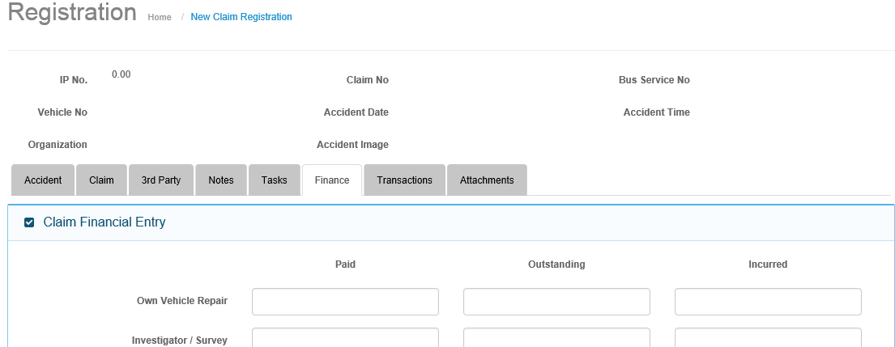

Amend to Claims Payment

Amend to Claims Payment

Incurred = a+b+c

Amend to -Outstanding Reserve (c)

New Column -Total Payment (a +b)

Change to – Total Payment before This Payment (a)

New Column -This Payment (b)

